**Assignment Instructions**

**This is a two (2) part assignment. In part 1, you will complete a Cisco lab. In part 2, you will create your own Packet Tracer file to practice for the project.**

**General Instructions:**

1. Unzip the file PacketTracerAndLabs.zip under "IT Infrastructure Project Assignments".
2. In the zip file PacketTracerAndLabs.zip, install Packet Tracer using the .exe file “Cisco Packet Tracer 6.2 for Windows Student Version.exe”.
3. Open the PDF in the zip file for an introduction to Packet Tracer.
4. A popup window will exist when you open the .PKA file using Packet Tracer, please make sure you can see the pop-up window with the instructions in Part 1.
5. You must use the Packet Tracer version 6.2, provided in the Project instructions zip file.  Instructors cannot open other versions due to licensing and will not be able to open incompatible versions, resulting in loss of points.
6. Assignments that do not use Packet Tracer 6.2 **will NOT be given credit or re-attempts.**
7. Leave all passwords blank on devices in Packet Tracer so that your assignment can be graded properly.
8. Submit your Packet Tracer file. **Non-working Packet Tracer files and/or solutions from the Internet will NOT be given credit.**
9. Submit one (1) Microsoft Word document with your answers to each question.  Take screenshots that include your Operating System data and time stamp of each solution working in Packet Tracer and post these in appendices in the Word document.
10. **Assignments without proper Screenshots of your solutions working in Packet Tracer will NOT be given credit.**
11. Please see the example screenshot for how to create proper screenshots for your assignments and projects.

**ALL SCREENSHOTS MUST FOLLOW THIS EXAMPLE**

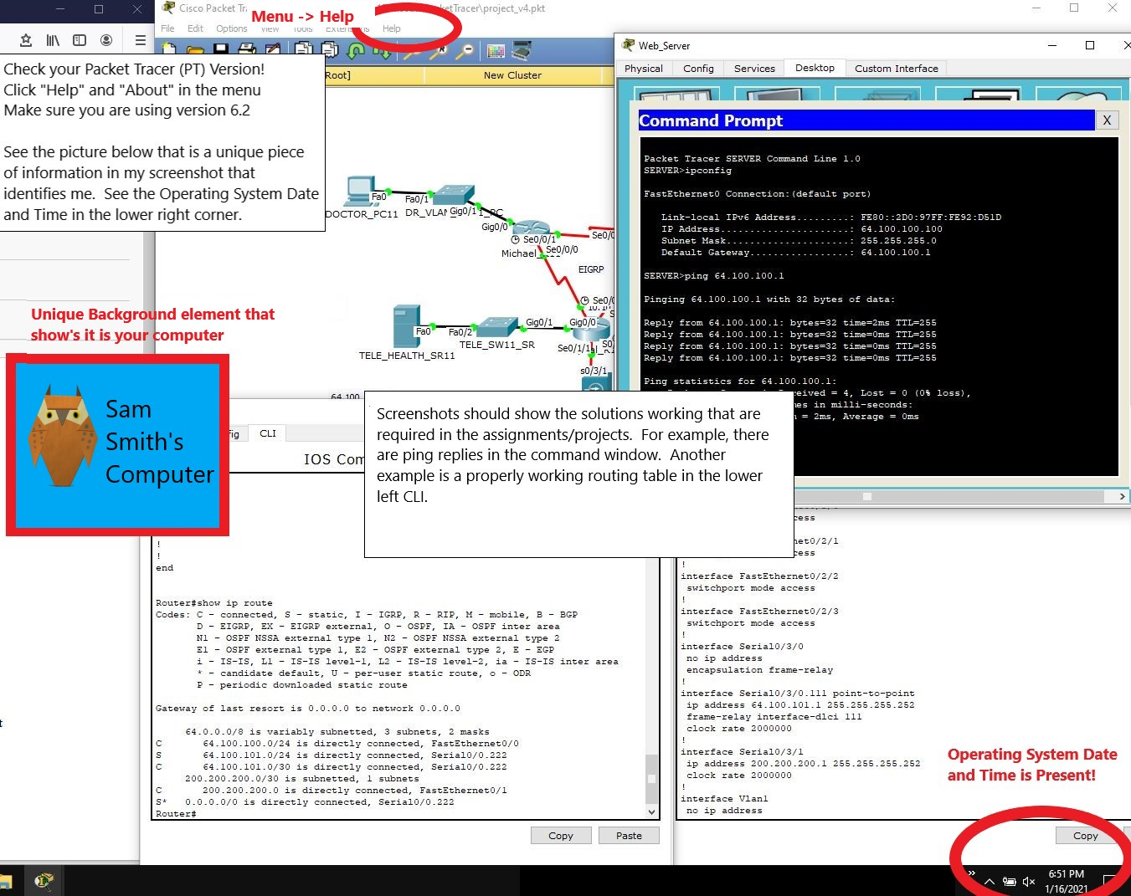

PART 1: Packet Tracer – Skills Integration Challenge

1. Topology

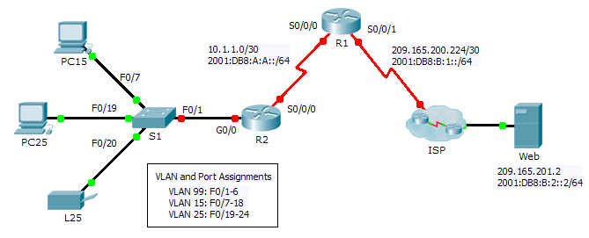

1. Addressing Table

|  |  |  |  |  |
| --- | --- | --- | --- | --- |
| Device | Interface | IPv4 Address | Subnet Mask | IPv4 and IPv6 Default Gateway |
| IPv6 Address/Prefix | |
| R1 | S0/0/0 | 10.1.1.2 | 255.255.255.252 | N/A |
| 2001:DB8:A:A::2/64 | | FE80::1 |
| S0/0/1 | 209.165.200.226 | 255.255.255.252 | N/A |
| 2001:DB8:B:1::2/64 | | FE80::1 |
| R2 | G0/0.1 | 192.168.1.193 | 255.255.255.224 | N/A |
| 2001:DB8:A:1::1/64 | | FE80::2 |
| G0/0.15 | 192.168.1.1 | 255.255.255.128 | N/A |
| 2001:DB8:A:15::1/64 | | FE80::2 |
| G0/0.25 |  |  | N/A |
| 2001:DB8:A:25::1/64 | | FE80::2 |
| G0/0.99 | 192.168.1.225 | 255.255.255.224 | N/A |
| 2001:DB8:A:99::1/64 | | FE80::2 |
| S0/0/0 | 10.1.1.1 | 255.255.255.252 | N/A |
| 2001:DB8:A:A::1/64 | | FE80::2 |
| S1 | VLAN 99 | 192.168.1.226 | 255.255.255.224 | 192.168.1.225 |
| PC15 | NIC | 192.168.1.2 | 255.255.255.128 | 192.168.1.1 |
| 2001:DB8:A:15::2/64 | | FE80::2 |
| PC25 | NIC |  |  |  |
| 2001:DB8:A:25::2/64 | | FE80::2 |
| L25 | NIC |  |  |  |
| 2001:DB8:A:25::A/64 | | FE80::2 |

1. Background

This activity allows you to practice a variety of skills including configuring VLANs, PPP with CHAP, static and default routing, using IPv4 and IPv6. Due to the sheer number of graded elements, you can click **Check Results** and **Assessment** **Items** to see if you correctly entered a graded command. Use the **cisco** and **class** passwords to access privileged EXEC modes of the CLI for routers and switches.

1. Requirements

**Addressing**

* The addressing scheme uses the 192.168.1.0/24 address space. Additional address space is available between VLAN 15 and VLAN 1. VLAN 25 needs enough addresses for 50 hosts. Determine the subnet and complete the subnet table below.

|  |  |  |  |
| --- | --- | --- | --- |
| VLAN | IPv4 Subnet Address | Subnet Mask | Hosts |
| 1 | 192.168.1.192 | 255.255.255.224 | 20 |
| 15 | 192.168.1.0 | 255.255.255.128 | 100 |
| 25 |  |  | 50 |
| 99 | 192.168.1.224 | 255.255.255.224 | 20 |

* Complete the **Addressing Table** by assigning the following addresses to VLAN 25:
  1. **R2** **G0/0.25** - First IPv4 address
  2. **PC25** - 2nd IPv4 address
  3. **L25** - Last IPv4 address
* Configure IPv4 addressing on the necessary end devices.
* On **R2**, create and apply IPv4 and IPv6 addressing to the G0/0.25 subinterface.

**VLANs**

* On **S1**,create VLAN 86 and name it **BlackHole**.
* Configure **S1** ports in static mode with the following requirements:
  1. **F0/1** is the native trunk for VLAN 99.
  2. **F0/7 - F0/18** as access ports in VLAN 15.
  3. **F0/19 - F0/24** as access ports in VLAN 25.
  4. **G1/1 - 2** and **F0/2 - F0/6** are unused. They should be properly secured and assigned to the **BlackHole** VLAN.
* On **R2**, configure inter-VLAN routing. VLAN 99 is the native VLAN.

**PPP**

* Configure **R1** and **R2** to use PPP with CHAP for the shared link. The password for CHAP is **cisco**.

**Routing**

* On **R1**, configure IPv4 and IPv6 default routes using the appropriate exit interface.
* On **R2**,configure anIPv6 default route using the appropriate exit interface.
* Configure IPv4 OSPF using the following requirements:
  1. Use process ID 1.
  2. Routers **R1** and **R2** are in area 0.
  3. **R1** uses router ID 1.1.1.1.
  4. **R2** uses router ID 2.2.2.2.
  5. Advertise specific subnets.
  6. On **R1**, propagate the IPv4 default route created.
* Configure IPv6 OSPF using the following requirements:
  1. Use process ID 1.
  2. Routers **R1** and **R2** are in area 0.
  3. Configure OSPF on appropriate interfaces on **R1** and **R2**.
  4. **R1** uses router ID 1.1.1.1.
  5. **R2** uses router ID 2.2.2.2.

**Troubleshooting and Explanations**

1. Show screenshots of all configurations.
   * 1. Configure static IPv4 addresses based on the created IP address table
   1. 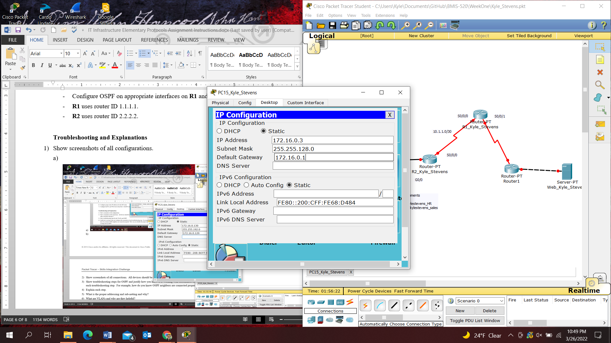
   2. 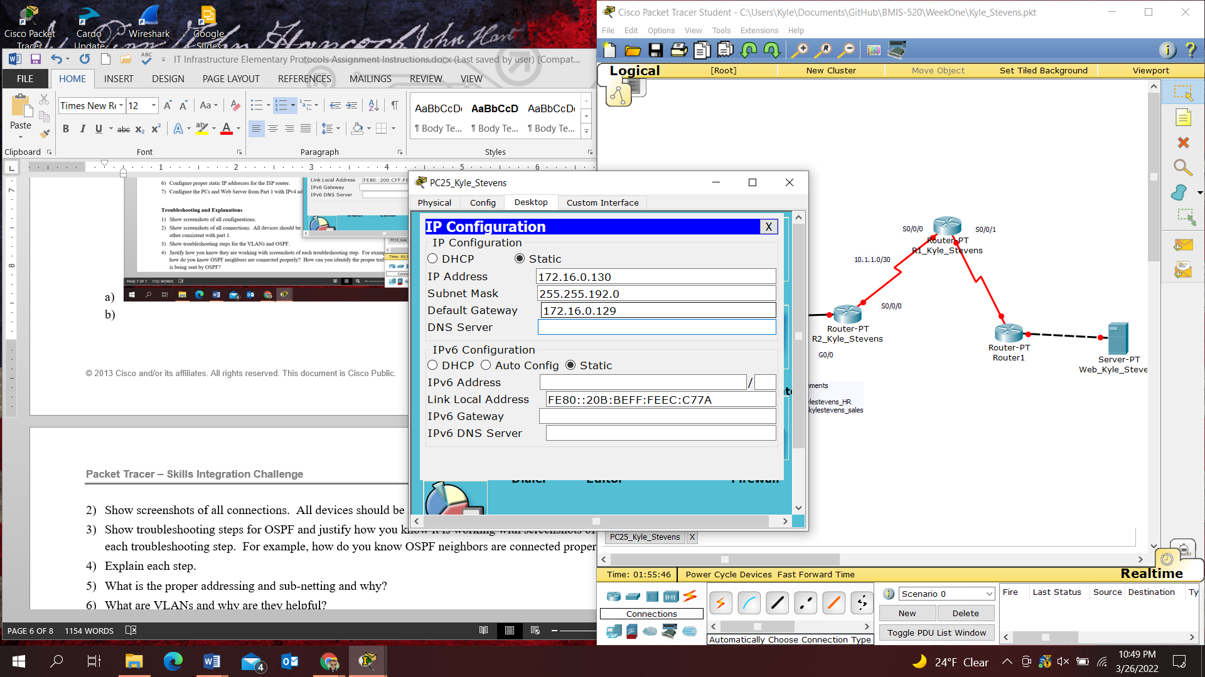
   3. 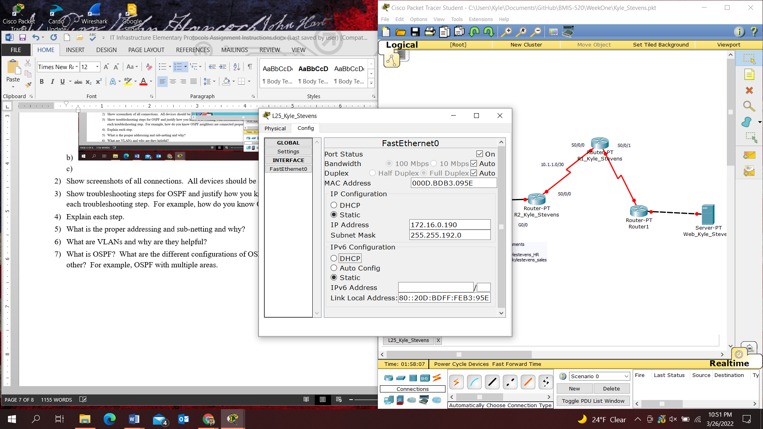
   4. 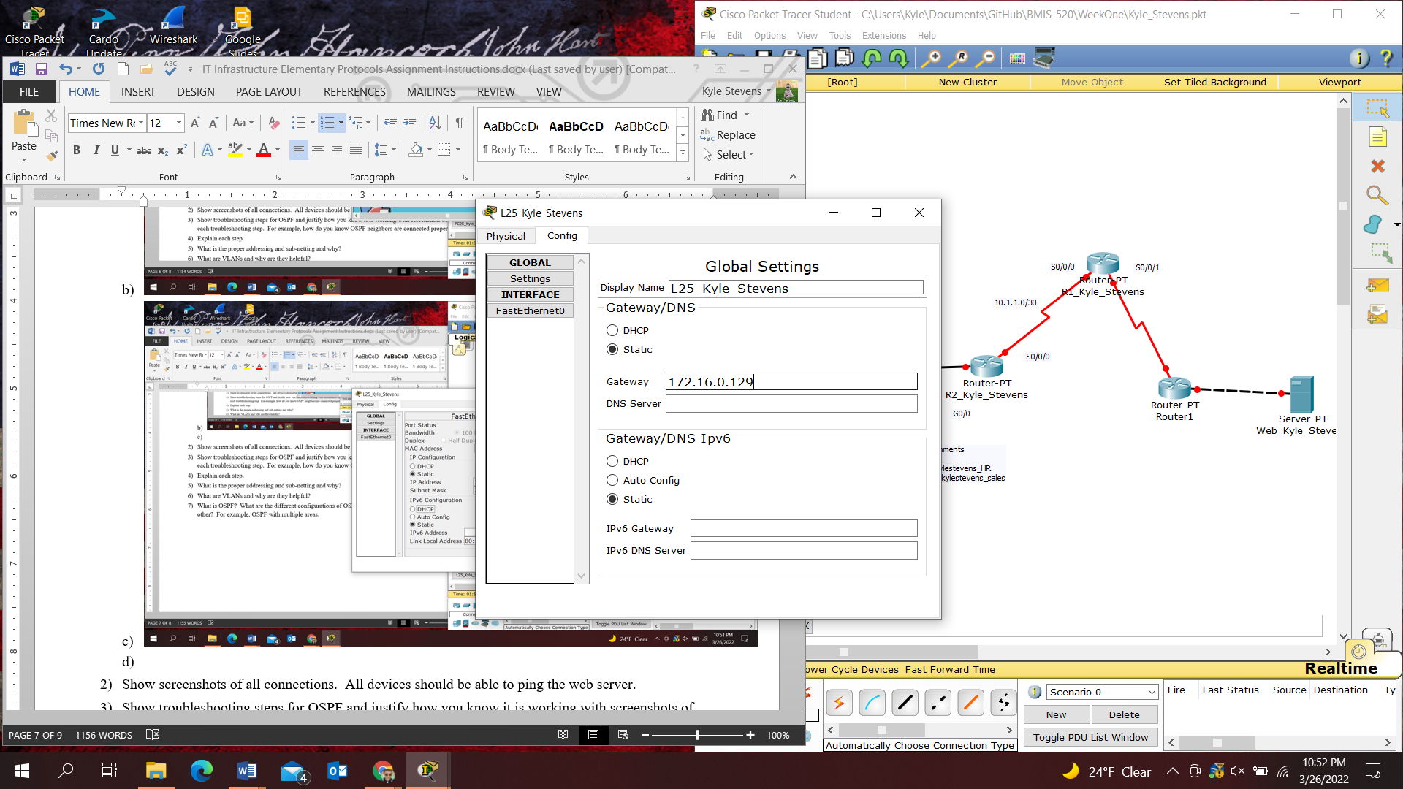
      1. Create and apply IPv4 addressing to the GigabitEthernet interface on R2_Kyle_Stevens
   5. 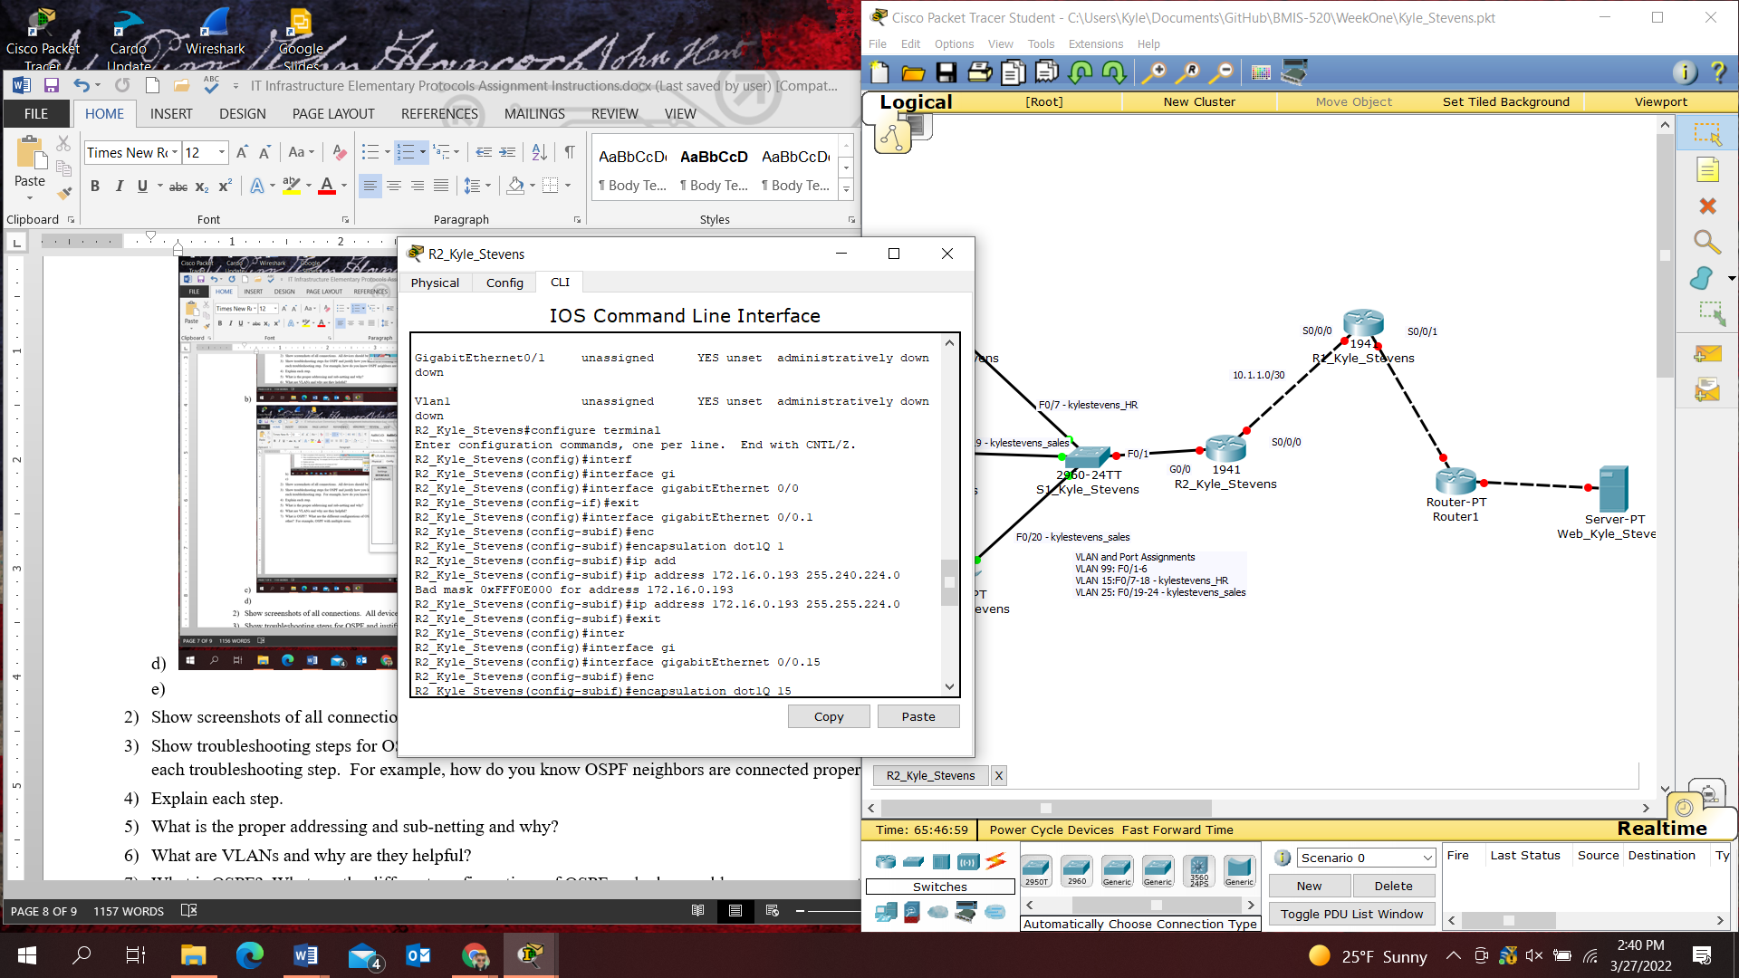
   6. 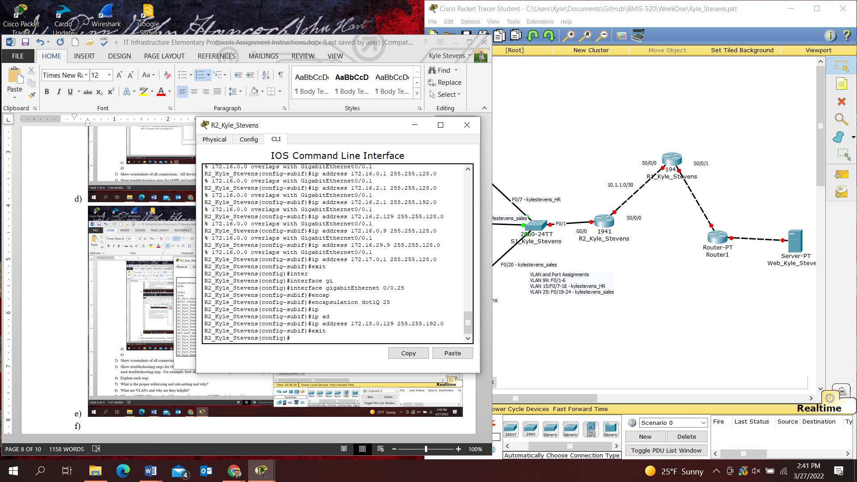
   7. 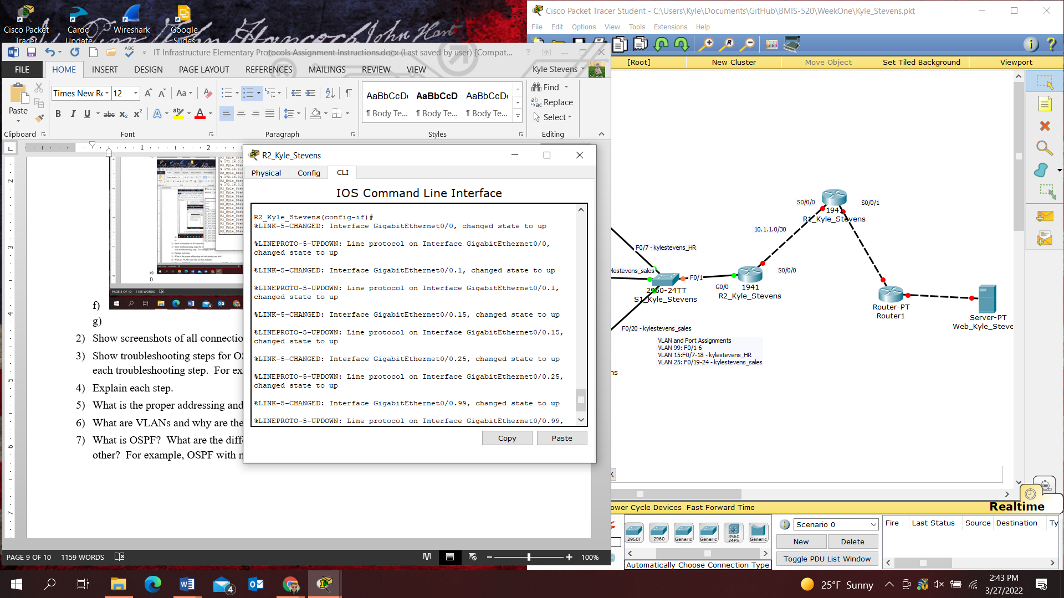
      1. IPv4 addresses assigned
   8. 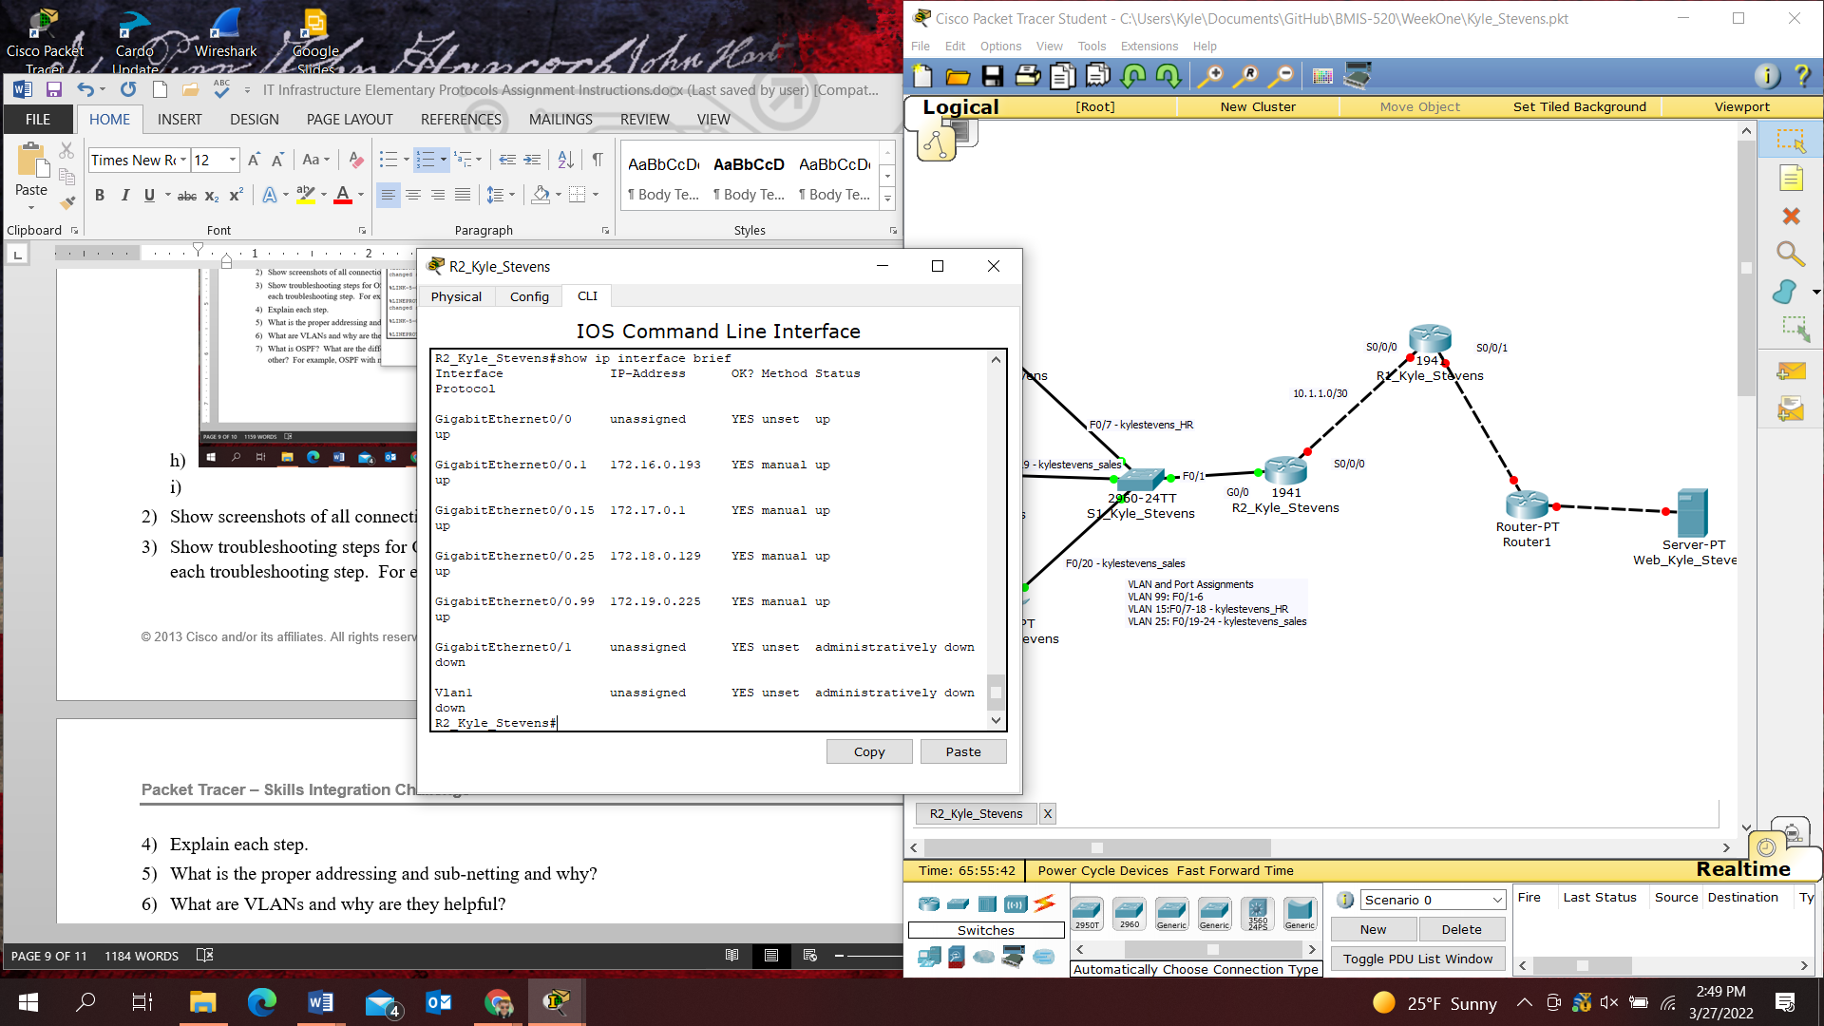
      1. Configure S1_Kyle_Stevens ports in static mode following the above requirements
   9. 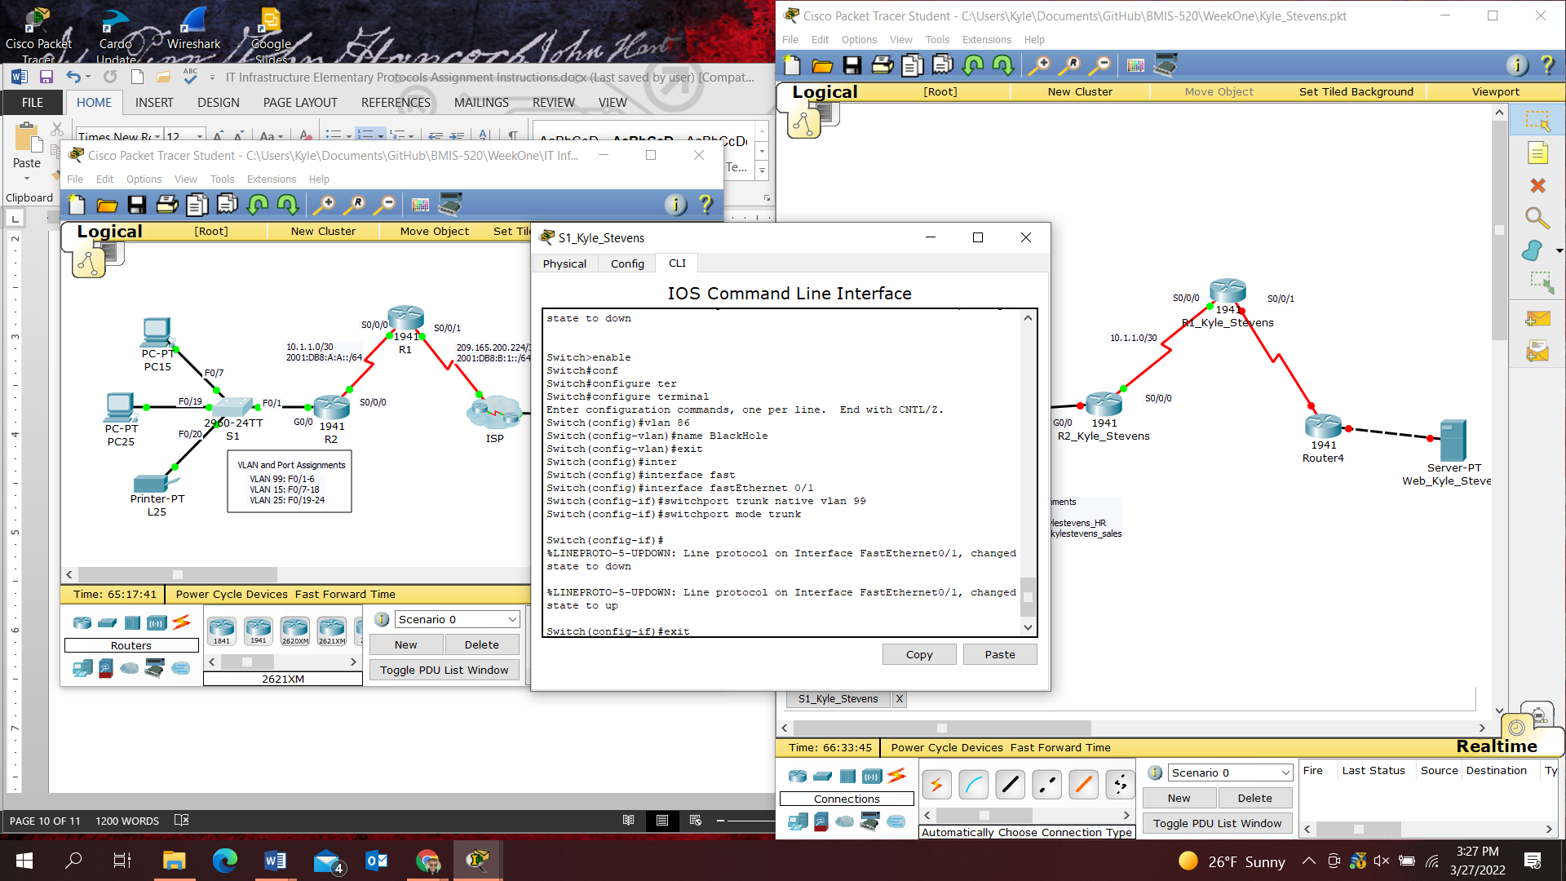
   10. 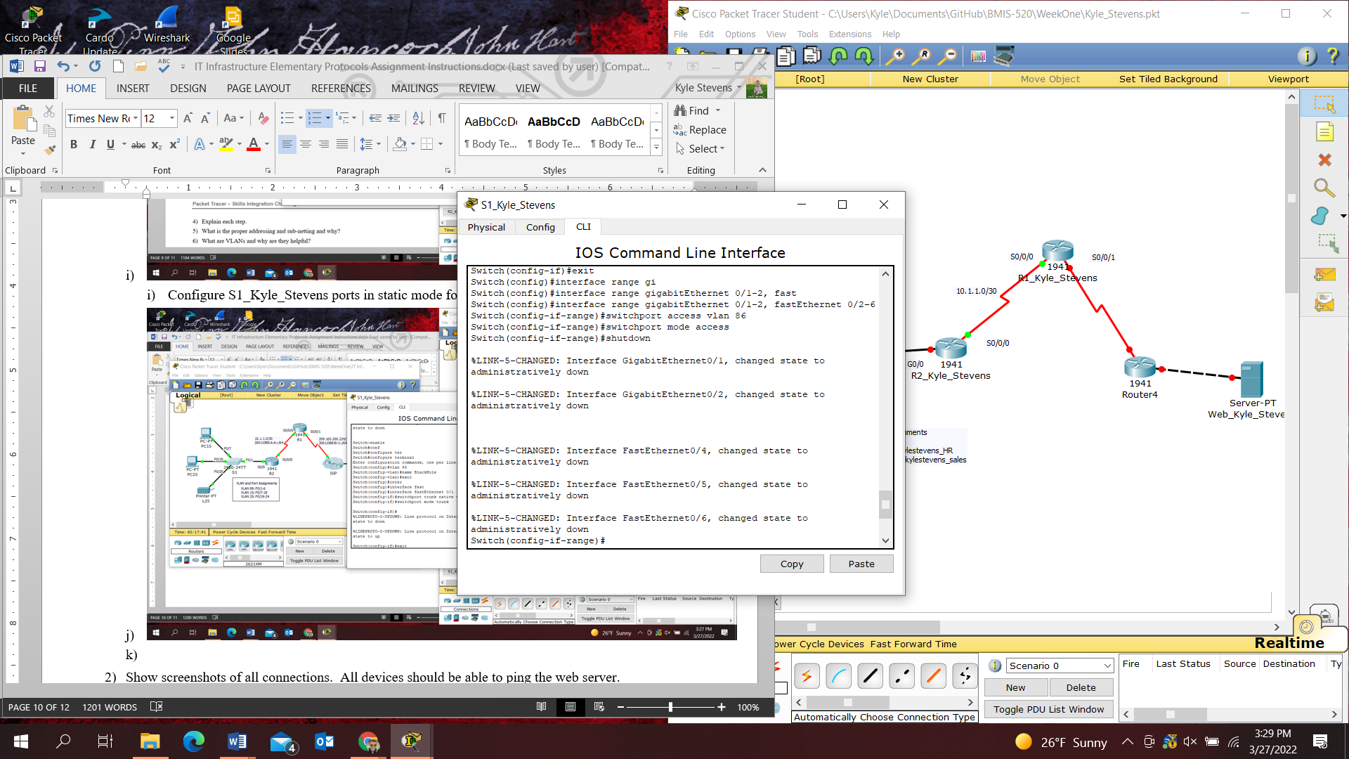
   11. 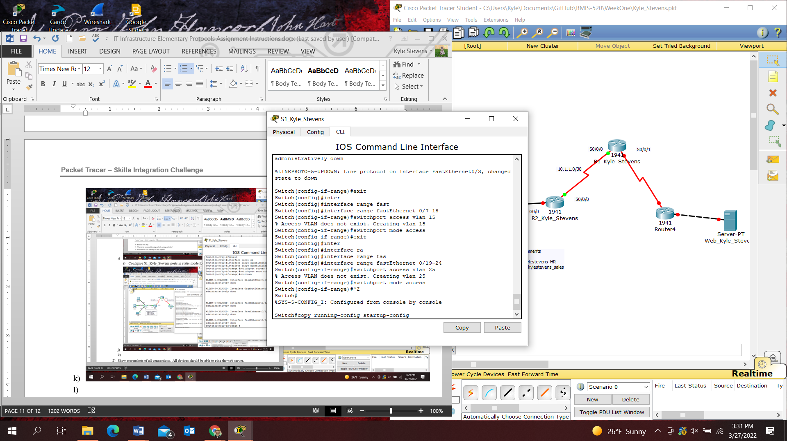
       1. Configure R1 and R2 to use PPP with CHAP for the shared link
   12. 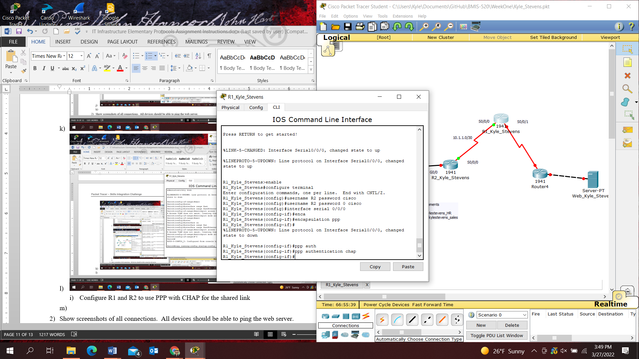
   13. 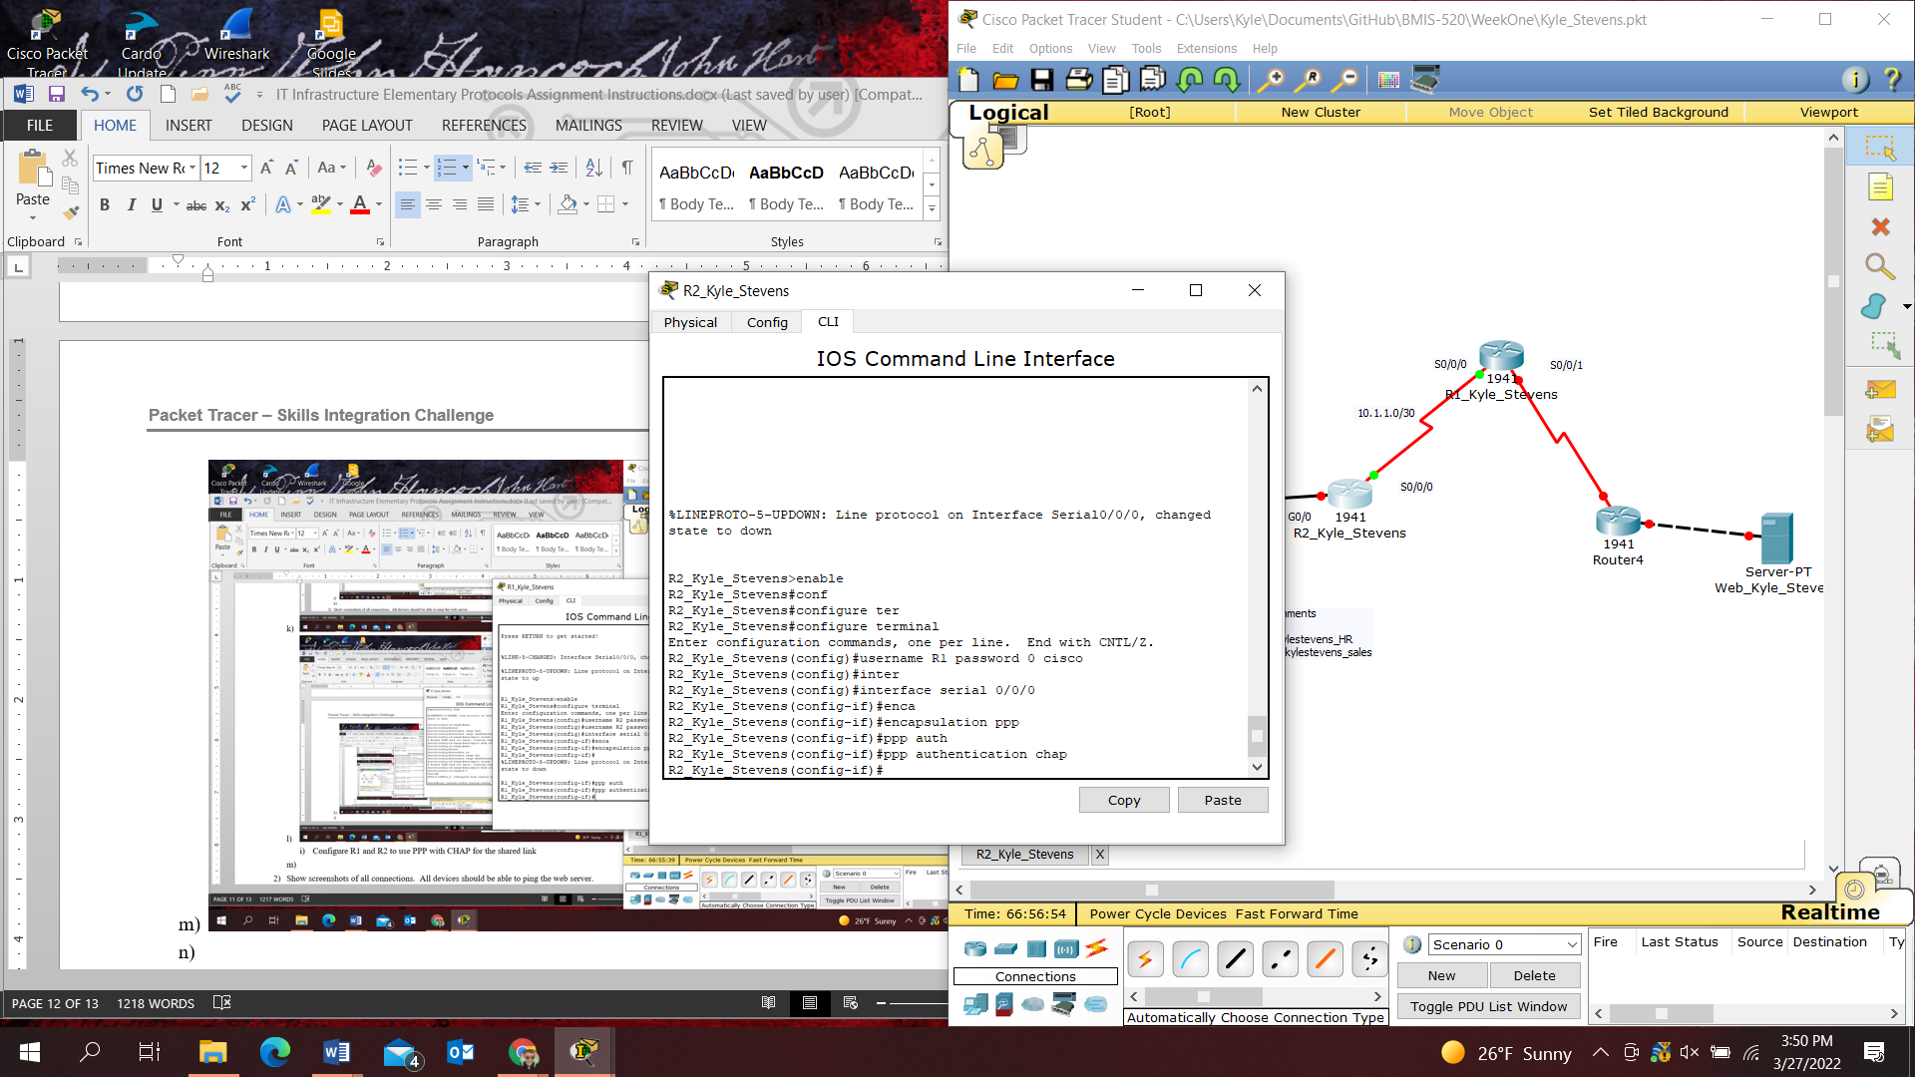
       1. Configure IPv4 default routes
   14. 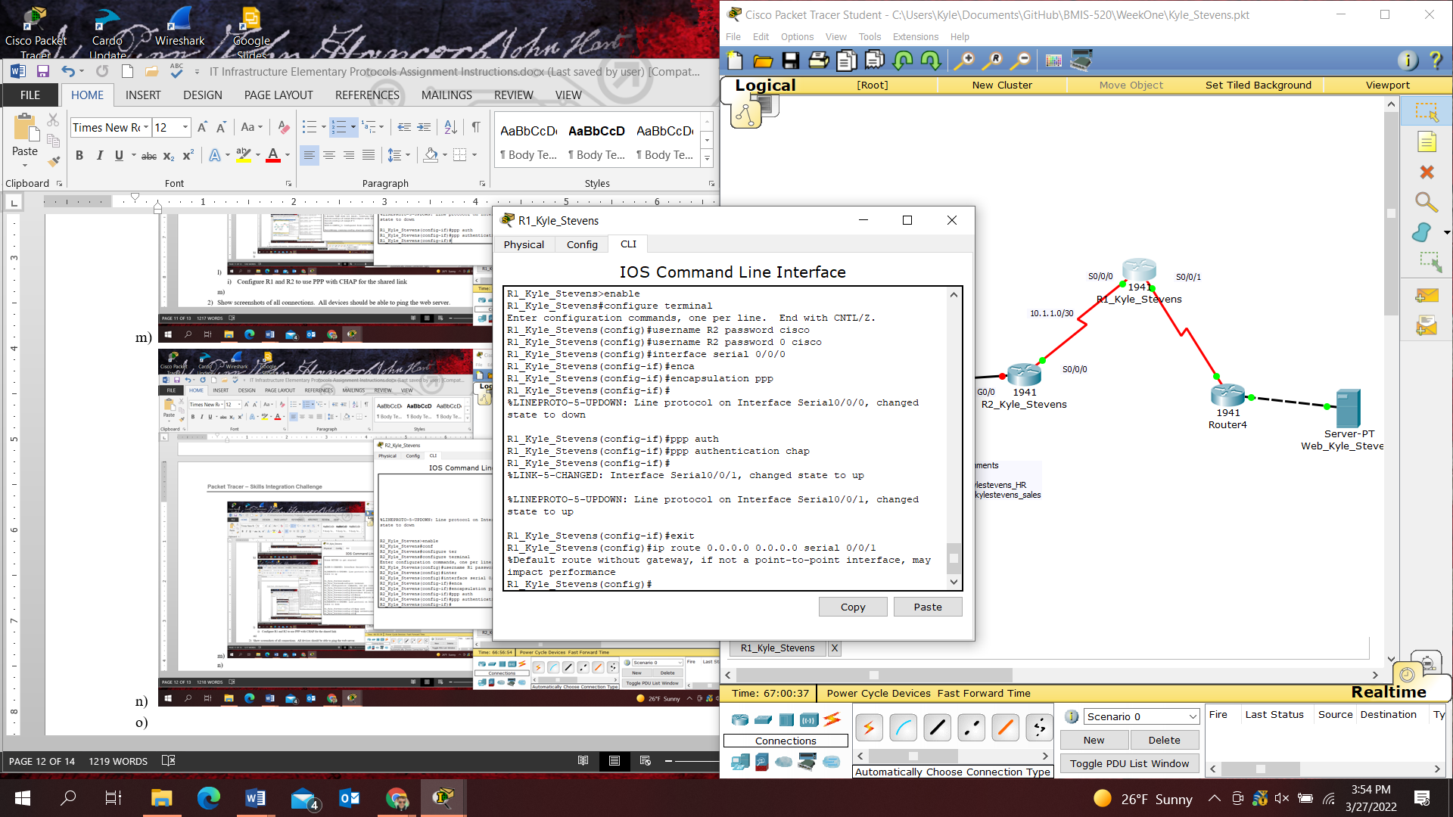
   15. 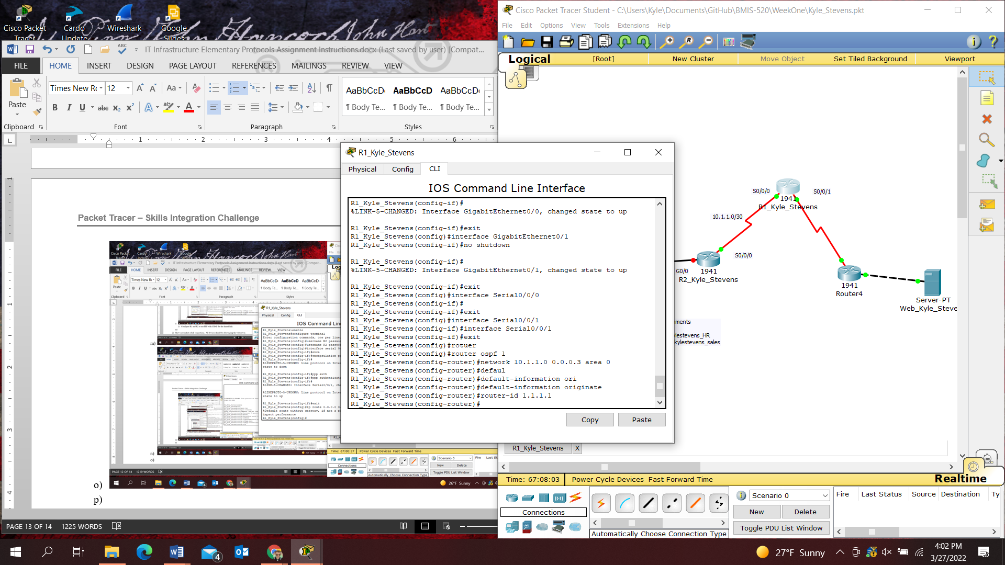
   16. 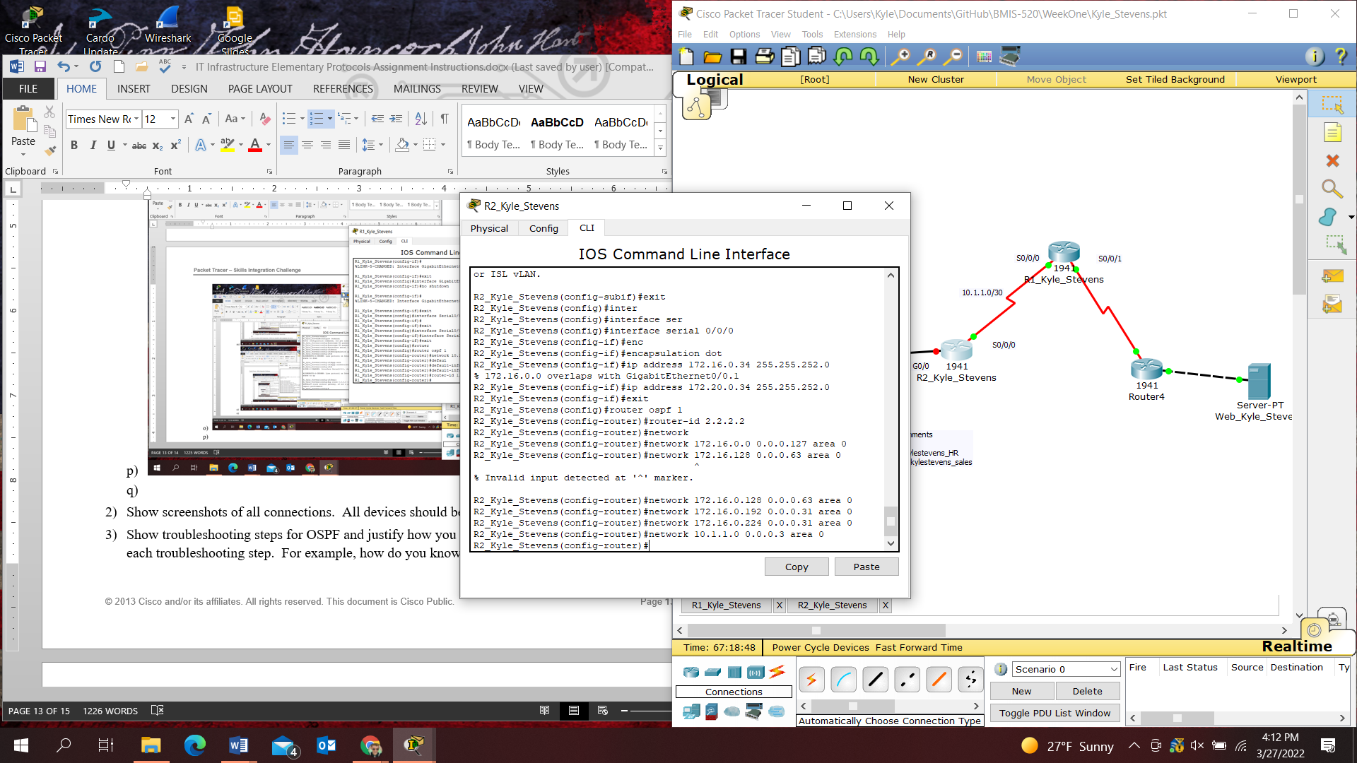
2. Show screenshots of all connections. All devices should be able to ping the web server.
3. Show troubleshooting steps for OSPF and justify how you know it is working with screenshots of each troubleshooting step. For example, how do you know OSPF neighbors are connected properly?
   1. Each router stores a topology of the entire network layout and therefore can calculate the shortest/fastest path the data will need to traverse to reach it specified endpoint.
4. Explain each step.
5. What is the proper addressing and sub-netting and why?
   1. 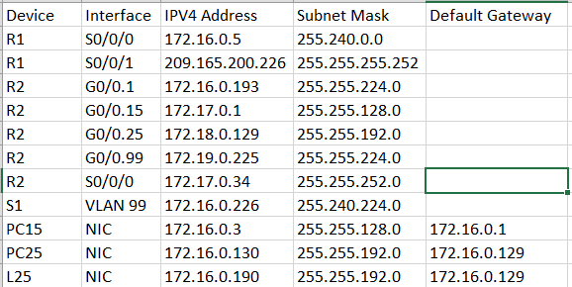
   2. IP addresses within the specified range for Class B IP Addresses
6. What are VLANs and why are they helpful?
   1. Virtual Local Area Networks. It is a collection of network devices that communicate as if they are made up of a single LAN, but they exist as several different LAN segments. They allow for increased performance, more flexible network configuration, and less administrative oversight.
7. What is OSPF? What are the different configurations of OSPF and why would you use one over the other? For example, OSPF with multiple areas.
   1. Open Shortest Path First. It uses distributed IP routing throughout an autonomous system in an IP network. Routers exchange topology information with their neighboring devices. This allows data to be forwarded using the best end-to-end path to the destination. There are six OSPF configurations: intra-area, inter-area, external type 1, NSSA type 1, external type 2, NSSA type 2. Use OSPF with multiple areas to avoid overloading routers with a large internal routing table and database. This will allow the router to perform better as routers do not need to understand the entire topology, but rather a portion of it.

**PART 2: Now you try!**

**Instructions**

1. Open a new / blank Packet Tracer window that does not have any devices
2. Add the same devices from Part 1 but use your first name and last name as a prefix. For example, if your name is “Amy Smith”, router one will be named: “R1_Amy_Smith”. Router 2 will be named “R2_Amy_Smith” and so on.
3. Design a new IP address table for all devices using any IP address in the 172.16.0.0/12 prefix range or 172.16.0.0 to 172.31.255.255. All addresses can be IPv4 for simplicity.
4. Create the similar VLANs from Part 1 but name them with your first name and last name and a department like human resources (HR) and sales. For example, if your name is “Amy Smith” they should be:
   1. F0/1 is the native trunk for VLAN 99.
   2. F0/7 - F0/18 as access ports in VLAN amysmith_HR.
   3. F0/19 - F0/24 as access ports in VLAN amysmith_Sales.
5. Configure PPP and OSPF with the same configurations as Part 1. You only need to configure IPv4. IPv6 is not necessary.
6. Configure proper static IP addresses for the ISP router.
7. Configure the PCs and Web Server from Part 1 with IPv4 addresses.

**Troubleshooting and Explanations**

1. Show screenshots of all configurations.
2. Show screenshots of all connections. All devices should be able to ping the web server and each other consistent with part 1.
3. Show troubleshooting steps for the VLANs and OSPF.
4. Justify how you know they are working with screenshots of each troubleshooting step. For example, how do you know OSPF neighbors are connected properly? How can you identify the proper traffic is being sent by OSPF?